Table of Content

**I.** **Introduction** 3

**II.** **Related Work** 4

**III.** **Centralized vs. Mobile Vaccination Programs** 4

**IV.** **Simulation Setup of A Centralized Vaccination Program** 6

**V.** **Implementation of a Centralized Vaccination Program using GPenSIM** 7

**VI.** **Simulation Setup of A Mobile Vaccination Program** 9

**VII.** **Implementation of a Mobile Vaccination Program using GPenSIM** 11

**VIII.** **Results & Analysis Using The Municipality of Stavanger As a Study Case**  13

**IX.** **Future Improvements.** 16

Simulation of Mass Vaccination Programs using GPenSIM in Matlab

A Practical and Experimental approach between centralized and mobile vaccination programs

Mohammed Z. Guniem   
*Department of Electrical Engineering and Computer Science*  
*University of Stavanger*Stavanger, Norway  
[m.guniem@stud.uis.no](mailto:m.guniem@stud.uis.no)

Abstract

Vaccines of different types and purposes are very crucial for preventing the spread of deadly infectious diseases. Deploying vaccines in highly populated areas proves to be a great challenge that must be evaluated and planned thoroughly before relying on any possible mass vaccination program. This research highlights the significant differences between centralized- and mobile mass vaccination programs, then proposes a workflow for each of them, these workflows are used as a base foundation in a computer simulation using the GPenSIM tool in MATLAB. The results of the simulations from this project will be evaluated using the population in the municipality of Stavanger as a realistic study case.

Keywords

Mass-Vaccination-Programs, Simulation, Petri-Nets, GPenSIM, Matlab.

Motivation

Vaccination has long been a powerful tool in providing immunity against infectious diseases, which have otherwise been far more deadly without the mass production and distribution of effective vaccines to provide immunity against such deadly diseases.

Figure 1 below shows the fatality rate of major virus outbreaks worldwide in the last 50 years as of January 2020 provided by “statista.com” [1], a clear decrease of the fatality rate from 80% of the Marburg disease in 1967 to 9.6% of the SARS virus disease in 2002 highlights the importance and benefits of vaccination in the fight against new viruses and diseases.

This paper describes a practical project that aims to measure the effectiveness of a traditional centralized mass vaccination program in comparison with a more mobile mass vaccination program. The main goal of this project is to utilize the capabilities of the GPenSIM simulation tool in MATLAB to establish scientific proof of the strengths and weaknesses of the mentioned vaccination programs and their potentials in mass vaccination of the human population.

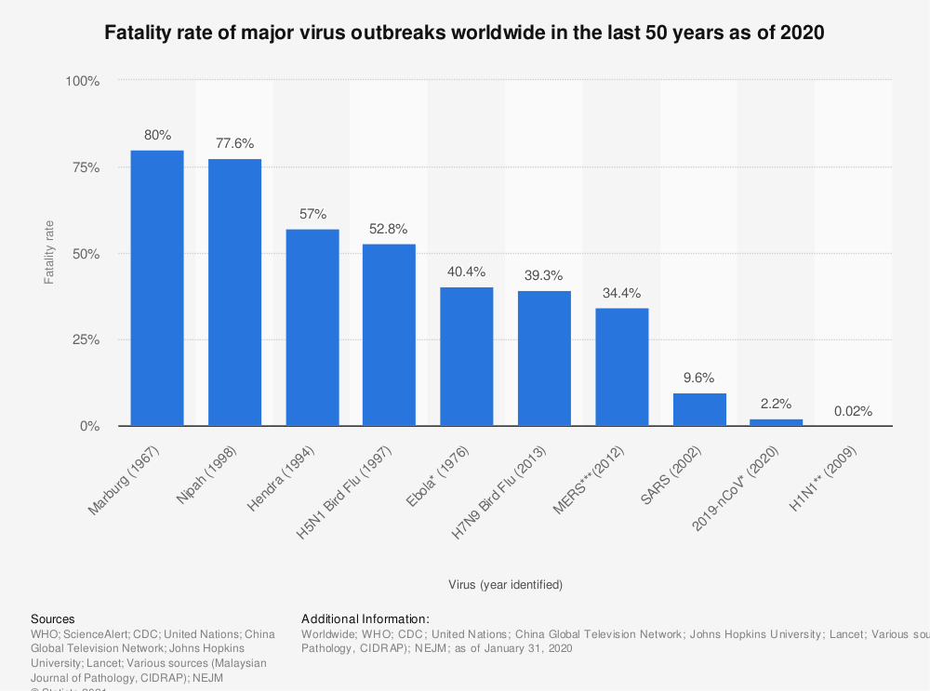

Figure 1, The fatality rate of some major virus outbreaks since 1976, [1].

# **Introduction**

The experienced history of vaccination has proven its effectiveness in protecting both human and animal populations against various diseases since its introduction in 900 CE [2]. However, most of the research has since then been focusing on developing the right vaccine against new outbreaks of diseases, with little effort to investigate how to distribute the developed vaccines across societies in an efficient and agile approach. The speed and effectiveness in which vaccine doses are distributed to society members is an important factor to limit and prevent the outbreaks of diseases across the human population, especially in tight urban environments where individuals are dependent on daily physical contact to keep the society functioning as desired.

This research takes on the challenge of comparing the two main types of mass vaccination programs; the first type of these programs provides the vaccine doses in a centralized fashion by asking residents to visit a vaccination center, while on the other hand, a decentralized vaccination program can be mobile by letting the health crew visit residents at their residence address to provide the vaccine doses.

Each vaccination program has its combination of advantages and disadvantages in terms of speed, quality, and environmental cost along with some other factors. The centralized vaccination has the advantage of being easy to set up and manage, with the disadvantage of being a contributing factor in spreading infectious diseases as people rush to the vaccination centers and wait in long queues to receive the vaccine, which increases the physical contact of society members and therefore the risk of a higher rate of infections. This physical contact can be minimized when a trained health crew visits residents at their homes to provide the vaccine, but this mobile vaccination program still comes at a cost of more management and coordination of the operations during the vaccination process.

This research will put each vaccination program under a magnifying glass to try to reveal their hidden effects and establish a better understanding of their efficiency. We start by building a ground foundation of the process that each society member must go through to get a dose of the vaccine in both centralized and mobile vaccination programs. Then move on to constructing two Petri nets[1] that will be used to implement two separate technical simulations of both vaccination programs using the GPenSIM tool in MATLAB. The interpretation of these GPenSIM simulations can help achieve the goal of this research by establishing an understanding of the strengths and weaknesses in each vaccination program during various conditions and situations. But first, let’s dive into some related work that has been contributed in previous research.

# **Related Work**

Exploring the aspect of managing and improving the flow of mass vaccination programs leads us to a collection of related work that can be used as a starting ground before launching into further details in this area.

One interesting research paper has recently been published under the title of ***“Mass production methods for mass vaccination: improving flow and operational performance in a COVID-19 mass vaccination center using Lean” Iain Smith & David Smith [4].*** The paper of this research describes multiple considerations, challenges, and strategies associated with mass vaccination programs and their impact on the operation flow of vaccine deployment, an example of the extent of this research is studying the cycle time of various processes during the progress of vaccination programs.

A deeper insight into mass vaccination can be provided from the published book having the title ***“Mass Vaccination: Global Aspects - Progress and Obstacles” by Stanley A. Plotkin [5].*** This book addresses the importance of intelligent management of mass vaccination programs and highlights some of the benefits of having the right strategy behind the operations of mass vaccination.

Since this project aims to implement two computer simulations of the centralized and mobile vaccination programs using the globally used GPenSIM tool, it has the potential to benefit from the published book by the same author of this GPenSIM simulation tool under the title ***“Modeling Discrete-Event Systems with GPenSIM An Introduction” by Reggie Davidrajuh [6]***. This book explains the different features and details of the GPenSIM simulation tool and represents a useful guide under the development of simulations, and later in further extensions and improvements of existing simulations.

# **Centralized vs. Mobile Vaccination Programs**

The process that each vaccine receiver must go through is described as the workflow of the vaccination program, these workflows can vary in small and big details across environments and up to many factors. In this research, we will propose two simplified common approaches of such processes for both centralized and mobile vaccination programs.

Starting with the centralized vaccination program, we assume that visitors arrive at the vaccination center after booking an appointment and that the rate of arrival is known to us, for example, 1 visitor per minute. Upon arrival, the visitor should be registered at a registration desk before queueing up to receive the vaccine from a trained health personal, then hold in another queue to occupy a waiting room for observation of any unexpected side effects and reactions that might show within half an hour after receiving the vaccine. The process of registering a new visitor is estimated to take 5 minutes on average and requires the help of one staff member at duty. similarly, the vaccination process is expected to take 10 minutes on average and requires the help of one trained health personal to inject the vaccine into the receiver’s body in a safe way. At last, vaccine receivers are required to wait for 30 minutes in isolated observation rooms available at the vaccination center before leaving. This workflow is visualized below on the left side of figure 2.

The previously proposed workflow of a centralized vaccination program is said to be a visitor-oriented flow, as visitors are moving from one stage to another through the vaccination center. This is different for a mobile vaccination program where health personals are dispatched from one street to another to visit residents at their homes and provide them with the vaccine, making this workflow more oriented to health personal than it is to the vaccine receivers.

The proposed mobile workflow of this research is provided on the right side of figure 2. It starts by dispatching a vaccination bus with one driver and one health personal from one street to another, which is a process that is expected to take 15 minutes on average. After arriving at the target street, the vaccination process can start by visiting residents at their homes in this street, or by letting the residents of the street queue up to receive their dose in the vaccination bus, either way, it is estimated to take 10 minutes to provide one dose of vaccine as in the centralized vaccination program. After vaccinating the residents of the targeted street, the vaccination bus needs a turnaround time that is expected to take 1 minute before starting to drive to the next target street.

To keep the focus on the main operations of vaccine distribution, we assume that we have an available response team that has sufficient capacity to respond to any side effects experienced by any of the vaccine receivers. For this reason, we will not include the details of the intervention from this response team in the main workflows of this research. But it is indeed recommended to extend this research by integrating this response operation into the main workflow as it would make the simulation more realistic and reliable in the future.

Figure 2, The proposed workflows of both centralized(left) and mobile(right) vaccination programs in this research.

# **Simulation Setup of A Centralized Vaccination Program**

Centralized vaccination takes place in a fixed location where residents arrive at the vaccination center to receive a dose of the available vaccine. The process of receiving a dose of this vaccine is built around the idea of moving visitors from one stage to another and maintaining several intermediate places or queues between each stage.

According to the proposed workflow on the left side of figure 2, centralized vaccination can be divided into 3 stages based on the purpose of each stage:

* Registration

This is the first stage, and it has the purpose of verifying and registering a visitor upon arriving at the vaccination center, and before receiving a dose of the vaccine. This stage is expected to take 5 minutes per visitor on average, and it is performed by one staff member per visitor.

* Vaccination

After registration, a visitor moves on to receive a dose of the vaccine from one trained health worker, which is a process that is estimated to take 10 minutes per visitor on average.

* Waiting for any side effects and reactions

Vaccines can cause severe allergic reactions and other side effects that can harm the person receiving the vaccine if it is not dealt with by a team of paramedics available on the premises. Therefore, it is important to wait for at least 30 minutes before leaving the vaccination center. The waiting should also happen in isolated rooms to avoid infections between visitors because the body of the receiver still hasn’t gained the required level of immunity against the targeted disease.

The visitors must stand in queue places waiting for their turn to enter the next stage. This in turn makes visitors vulnerable to catching the targeted disease while they are at the vaccination center, but the length of these queues can still be controlled by requiring the visitors to book an online appointment in advance before attending to receive the vaccine.

Figure 3 below shows a proposed solution of a Petri net system flow that visualizes the workflow of this centralized vaccination. In this Petri net, we have 4 types of transitions, these transition types are “tVISITOR”, “tREGISTRATION”, “tVACCINATION”, and “tWAITING” each representing the processes of appointment booking, registration, vaccination, and waiting respectively.

The number of transitions is dependent on the following factors:

* The number of available resources of staff members to handle the registration of visitors.
* The number of available health workers to handle the vaccination process.
* The number of waiting rooms to be used for observation after receiving the vaccine.

In the Petri net drawn in figure 3, there are 1 staff member available who can register 1 visitor per 5 minutes, 2 health workers who can register 2 visitors per 10 minutes, and 6 waiting rooms that can host 6 visitors each 30 minutes. This is the optimal setup of resources as 1 staff member can process 6 visitors in 30 minutes, and 2 health workers can together process 6 visitors in 30 minutes, then the 6 waiting rooms do also process 6 visitors per 60 minutes. Assigning any more resources at one of these stages and leaving the other resources as they are can theoretically be seen as an excessive and unnecessary measure. Also, on the other hand, any shortage of resources at any stage can cause ring effects and impact the progress of other stages in the system.

The Petri net model materializes the progress from one transition to another in 4 places where tokens in “P1” denote visitors that have arrived at the vaccination center but still has not been registered yet, while tokens in “P2” denote registered visitors waiting to be vaccinated, and tokens at “P3” denote vaccinated visitors trying to access a waiting room and wait for 30 minutes before leaving the premises. Monitoring the number of tokens at “P4” allows us to track how many visitors the system was able to process at each time of the simulation.

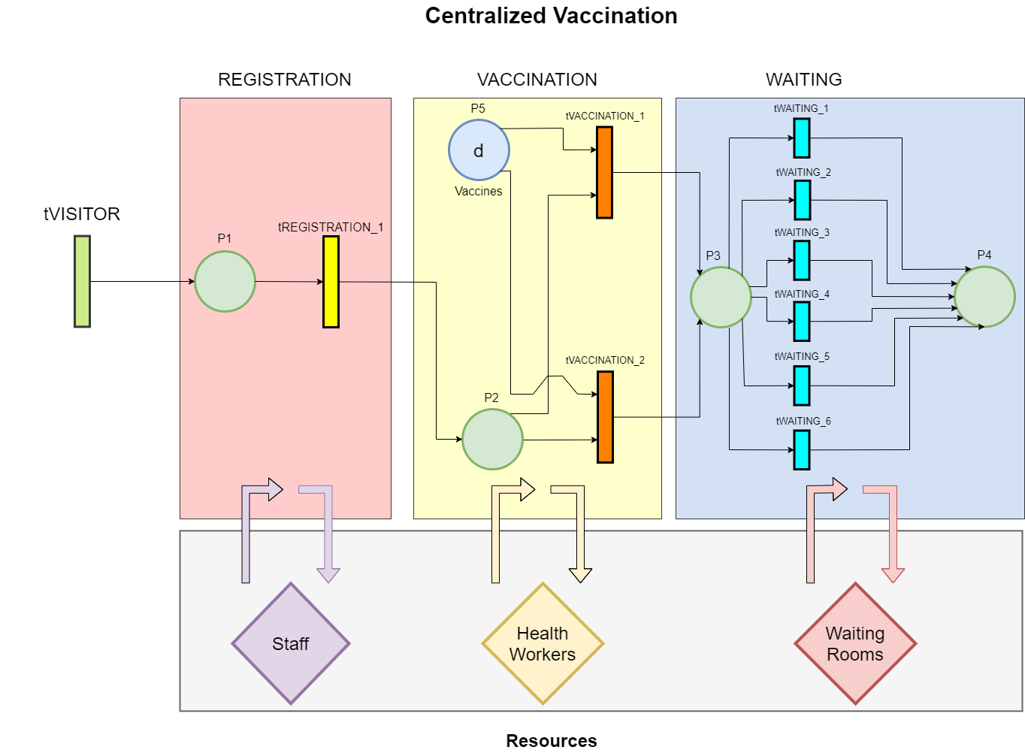

Figure 3, A proposed Petri net of centralized vaccination.

# **Implementation of a Centralized Vaccination Program using GPenSIM**

Now that we have constructed a Petri net for the centralized vaccination program, it is time to start implementing the logic of this program into a computer simulation using the powerful capabilities of the GPenSIM tool in MATLAB.

The implemented code of this simulation is to be found inside the folder named “Centralized Vaccination” in the attached source code. It consists of the following 4 files:

* Petri net Definition File (PDF)

As its name suggests, this file defines the Petri net of the system to be simulated, it contains the 3 necessary sets that define the places, transitions, and arcs in the Petri net shown in figure 3.

* Common Pre-processor File

This file is used by the transitions of the types “tREGISTRATION_*”, “tVACCINATION_*” and “tWAITING_*” to acquire the needed resources before firing, these resources are one staff member, one health worker, and one waiting room, that is needed to enable the firing of the transition types of one “tREGISTRATION_*”, one “tVACCINATION_*” and one “tWAITING_*” transitions respectively.

In addition, this file also implements a pre-processer of the “tVISITOR” transition, that acts as a scheduler and generator of regular visitors to simulate new arriving visitors at the vaccination center, the time interval between visitors, and the number of visitors arriving at each firing is configured as a global variable in the main simulation file. Also in this file, it is possible to configure a close time of the vaccination center to stop receiving new visitors.

* Common Post-processor File

This file implements the release of any acquired resources after firing from the transition types of “tREGISTRATION_*”, “tVACCINATION_*”, and “tWAITING_*”.

* Main Simulation File (MSF)

This file is the one to run to kickstart this simulation, it starts by configuring the start and end real-time of the simulation, along with the close time where no more visitors arrive at the vaccination center. Then the interval between visitors, and the number of visitors that arrive at each interval is configured for the “tVISITOR” transition.

Furthermore, it is also required to determine the number of available resources from staff members to work with registration of new visitors, health workers to work with the vaccination process, and waiting rooms to host visitors for 30 minutes of observation each.

* A Dynamic Configuration File called “construct.m”

To make this simulation easily scalable, a series of methods are implemented in this file to construct the sets of firing times, transitions, and arcs in a compatible structure with GPenSIM.

This is because the system contains multiple transitions of the same type that can fire simultaneously, an example here is when we have an “n” number of staff members, then also an “n” number of “tREGISTRATION_” transitions are configured to process arriving visitors at “P1” and output tokens at “P2”, the same logic is applied to the “tVACCINATION_*” and “tWAITING_*” transitions.

The number of vaccine doses in place “P5” is configured by multiplying the number of available waiting rooms by 2 and then by 8 as the simulation is to run for 8 hours and each waiting room can host/process 2 visitors within 1 hour, then we are not going to need more doses of the vaccine than the bottleneck capacity of the available waiting rooms. However, and if needed the value of the configured number of available doses of the vaccine can be manually set by configuring the respective variable called “num_of_vaccines” in the main simulation file.

After implementing this simulation in GPenSIM, we are ready to fire it up and note the performance capability of centralized vaccination. In this simulation run, we are going to use the basic set of available resources of 1 staff member, 2 health workers, and 6 waiting rooms. This gives us a total of 1 “tREGISTRATION_*” transition, 2 “tVACCINATION_*” transitions, and 6 “tWAITING_*” transitions, with their dynamically constructed arcs from and to places 1 to 5 shown in the visualized Petri net in figure 3. We will also configure this simulation to receive 1 new visitor per 5 minutes to match the registration capacity of the one and only available staff member, and then set the close time of the “tVISITOR” transition to 15:30 to stop receiving any new visitors half an hour before ending the simulation by processing all visitors who are occupying the waiting rooms for the last time at this simulated working day.

The result of this simulation is shown in figure 4 below where at the final state 86 visitors have been successfully processed by the system and therefore placed in the final place “P4”.

It is also good to notice that the system takes about 45 minutes before it starts producing fully vaccinated and approved visitors, this is because any arriving visitor should spend at least 45 minutes before getting done with the entire vaccination process from the registering process that takes 5 minutes, through vaccination that takes 10 minutes and finally waiting for 30 minutes for any abnormal reactions to the vaccine.

The maximum observed queue length is 1 vaccinated visitor at “P3” waiting to access a waiting room on many occasions in the simulation, while we also experience a maximum waiting number of visitors of 1 person at places “P1” and “P2” in the very early start of beginning to receive visitors in the simulation. Which might be caused by the next and previous transitions pre-processing just at the same time. However, a maximum waiting of 1 person in each queue is not concerning since infection control can still be easily maintained if there is no more than one person in the same area waiting for the next stage.

It is also important to correctly configure the scheduling of arriving visitors according to the capacity of available resources to minimize the number of holding visitors at each intermediate place between transitions, thus preventing infections between holding visitors.

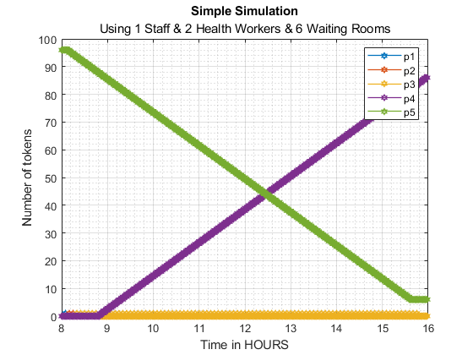

Figure 4, Simulation results of centralized vaccination using GPenSIM, and having a simple set of available resources of 1 staff member, 2 health personals, and 6 waiting rooms.

In the upcoming section of results and analysis, we are going to scale this set of available resources to match a real-life situation where we have more resources than what we had for this basic simulation, and then compare it with a near equal number of resources used in mobile vaccination to establish an understanding of differences in features and performance between centralized and mobile vaccination on a bigger scale. But first, let’s dive into the simulation of mobile mass vaccination and discuss its features and details.

# **Simulation Setup of A Mobile Vaccination Program**

Mobile vaccination offers residents the opportunity to receive a dose of the distributed vaccine at their residence without having to visit a vaccination center as in centralized vaccination. The idea behind mobile vaccination is to divide the available team of trained health workers into different batches and equip them with a vehicle or what is also known as a vaccination bus. These busses are then dispatched to each street in the targeted residence area, and health workers can either move on foot to vaccinate people at their homes or offer the vaccine to the residents of a certain street onboard the vaccination bus.

According to the proposed workflow on the right of figure 2, mobile vaccination can be divided into 3 stages based on the purpose of each stage:

* Dispatch

The operation of mobile vaccination starts with dispatching each health worker to a targeted street using a vaccination bus with its driver. Driving this vaccination bus to a new street address is expected to take 15 minutes on average from one street to another.

* Vaccination

After arriving at a new street, the health worker starts the process of vaccinating street residents one by one. This process is estimated to take 10 minutes on average to vaccinate each resident.

* Completion

This is the turnaround stage that is performed after all residents of the currently visited street have been vaccinated, and the bus can again get dispatched to a new street and so on. The turnaround time is assumed to be 1 minute for this simulation project.

Following this mobile vaccination setup, residents do not have to stand in long queues and can be visited by a health worker to receive a dose of the vaccine. This helps contain infections as a result of minimized physical contact between residents.

Figure 5 below shows a proposed solution of a Petri net that visualizes the workflow of mobile vaccination. In this Petri net, we have 3 types of transitions, these transition types are “tDISPATCH_*”, “tVACCINATION_*” and “tCOMPLETION_*”, each representing the processes of dispatching, vaccination, and turnaround completion respectively.

The number of transitions is dependent on the following factors:

* The number of available bus drivers to reach out to new streets.
* The number of available health workers to handle the vaccination process of street residents upon arrival.

In the Petri net shown in figure 4, we have chosen a small setup of 2 available bus drivers and 2 health workers for demonstration purposes, and because all stages go on concurrently, we must dynamically configure 2 “tDISPATCH_*” transitions, 2 “tVACCINATION_*” transitions and 2 “tCOMPLETION_*” transitions respectively for each stage of this mobile vaccination program, and one for each group of a health worker accompanied with a bus driver.

To keep this simulation as discrete as possible, the arcs between the dispatch transitions and the place “P5” outputs the configured average number of residents in each street of the targeted residence area denoted as “R”, which can be calculated by dividing the total number of residents in an area on the total number of streets in this residential area. This same number of residents “R” is consumed and outputted by the completion transitions upon the end of the vaccination process in a visited street, which is realized in the arcs from the place “P7” to each of the completion transitions, and the arcs from these completion transitions to the place “P8”. The sum of tokens in the places “P7” and “P8” can then be used to measure the number of fully vaccinated residents at each time of this simulation.

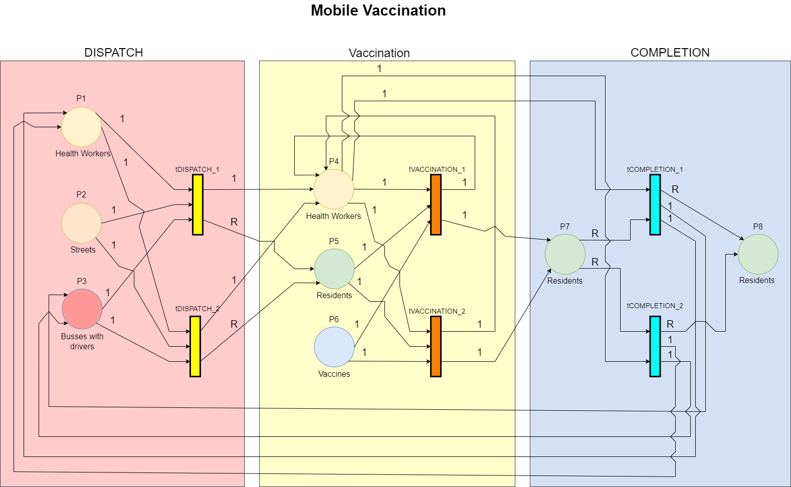

Figure 5, A proposed Petri net of mobile vaccination.

# **Implementation of a Mobile Vaccination Program using GPenSIM**

Starting from the Petri net of the proposed mobile vaccination program shown in figure 5, we are going to implement its logic into a computer simulation using the available GPenSIM tools in MATLAB.

The technical implementation of this simulation is founded inside the folder named “Mobile Vaccination” in the attached source code of this project; this implementation consists of the following 3 files:

* Petri net Definition File (PDF)

As for the implementation of centralized vaccination, this file also defines the Petri net of the mobile vaccination program, it contains the 3 necessary set definitions of the places, transitions, and arcs in the Petri net shown in figure 5.

* Main Simulation File (MSF)

This file is the one to run to kickstart the simulation of mobile vaccination, it starts by configuring the start and end real-time of this simulation. And requires the user to set the number of available health workers and vaccination busses with their drivers to be used under this simulation, along with the number of targeted streets to visit and vaccinate its residents.

Furthermore, the number of available doses of vaccine is set to equal the given total number of residents to vaccinate in the entire residential area. And an important constant to set is the average number of residents per street in the targeted area because it is needed to be used as a weight value of the arcs stretched from the “tDISPATCH_*” transitions to the place “P5” according to the Petri net in figure 5 to simulate the start of the vaccination stage upon arrival at a targeted street. And accordingly, from the place “P7” to the “tCOMPLETION_*” transitions to simulate the end of the vaccination stage at a targeted street and turnaround functionality to visit a new street.

* A Dynamic Configuration File called “construct.m”

Just as in the implementation of centralized vaccination and to make this simulation easily scalable, a series of methods are implemented in this file to construct the sets of firing times, transitions, and arcs in a compatible structure with GPenSIM.

This is because the system contains multiple transitions from the same type that can fire simultaneously, an example here is when we have an “n” number of health workers and an “n” number of bus drivers, then we should also grow the configured Petri net to include an “n” number of “tDISPATCH_*” transitions to dispatch a vaccination bus to a targeted street. The same logic is applied to dynamically configure an “n” number of “tVACCINATION_*” transitions and an “n” number of “tCOMPLETION_*” transitions.

To test our simulation in a simple way, we start by defining a small set of 2 health workers accompanied by 2 bus drivers and 2 vaccination busses, their mission is to vaccinate as many residents as possible from a total of 100 streets, giving an average of 20 residents per street, which is the number “R” shown by the Petri net in figure 5. This simulation will then run from 8 am to 4 pm to simulate one working day.

Figure 6 below shows the number of tokens in each place during the simulation, and at first, we are interested in how many residents can get vaccinated by a group of 2 repeatedly dispatched vaccination busses, which is the sum of tokens in the places “P7” and “P8” at 16 O’clock when the simulation ends, which is found to be 86 tokens, meaning that 86 residents have been fully vaccinated during this simulated day of mobile vaccination. This is surprisingly equal to the number of fully vaccinated residents in the implementation of centralized vaccination with similar available resources of health workers performed earlier in this project.

In addition to this observation, it is possible to notice the repeated waves of suddenly increasing and gradually decreasing number of tokens in place “p5”, where each period illustrates the vaccination process that is in progress at the currently targeted streets.

It is also useful to notice that the final number of streets left to vaccinate is 94 tokens left at place “p2”, meaning that 6 streets have been visited since we started from 100 streets in total. However, this does not mean that all residents in these 6 streets have been vaccinated as we can see that there are still tokens in place “P5” at the end time of this simulation.

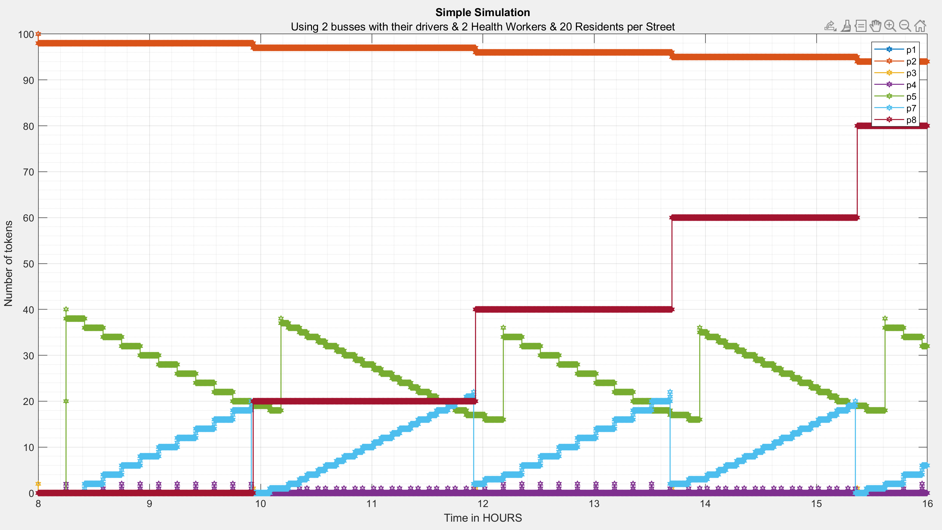

Figure 6, Simulation results of mobile vaccination using GPenSIM, and having a simple set of available resources of 2 health workers accompanied with 2 vaccination busses driven by 2 available drivers.

In the upcoming section of results and analysis, we are going to use the municipality of Stavanger to scale this set of available resources to match a real-life situation where we have more resources than what we had for this basic simulation of mobile vaccination, and then compare it with a similar number of resources used in centralized vaccination to establish an understanding of differences in features and performance between centralized and mobile vaccination on a bigger scale.

# **Results & Analysis Using The Municipality of Stavanger As a Study Case.**

In this section, we are going to use a real-world study case to better evaluate the differences in performance between centralized and mobile mass vaccination. We hereby choose the medium-sized municipality of Stavanger because of its moderate density of human population and its geographic spread across various environments such as mountains and islands in addition to areas of farming and residence.

In the previous setup and implementation of centralized and mobile vaccination, we kept the available resources to a minimum to simplify the idea behind each vaccination program and its mechanism. However, a medium-sized municipality like Stavanger is expected to have a higher quantity of resources under a coordinated vaccination program. An example of such capacity is shown in the following overview in table 1.

Now that we have established an overview of the resources that can be used in both centralized and mobile vaccination programs, we can put this number of resources into its respective implemented simulation which was built earlier in this project. This will allow us to spot the unique features of both vaccination programs and evaluate their performance in the municipality of Stavanger as a study case.

We start by simulating centralized mass vaccination using 7 staff members and 14 health personals, to work with the registration and vaccination process respectively, along with 42 available rooms to be used by the vaccinated visitors for observation. The result of this simulation is shown in figure 7 below.

Another simulation of mobile vaccination is also performed separately using the same number of 14 health personals accompanied with 14 vaccination busses where each bus has an assigned driver. Making 14 available teams to dispatch as each health personal, vaccination bus and its driver make up one dispatch team. The result of this mobile vaccination is visualized in figure 8 below.

Table 1, The expected quantity of human and material resources that can be provided by the municipality of Stavanger to be used during each vaccination program.

|  |  |  |
| --- | --- | --- |
| Resource | Centralized Vaccination | Mobile Vaccination |
| Staff members | 7 | Not needed |
| Health Personals | 14 | 14 |
| Waiting Rooms | 42 | Not needed |
| Vaccination Busses with drivers | Not needed | 14 |

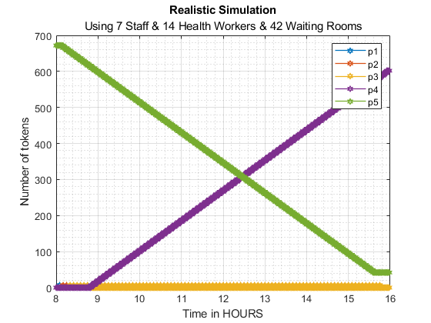

Figure 7, Simulation results of centralized vaccination using GPenSIM, and having a realistic set of available resources, consisting of 7 staff members, 14 health personals, and 42 waiting rooms.

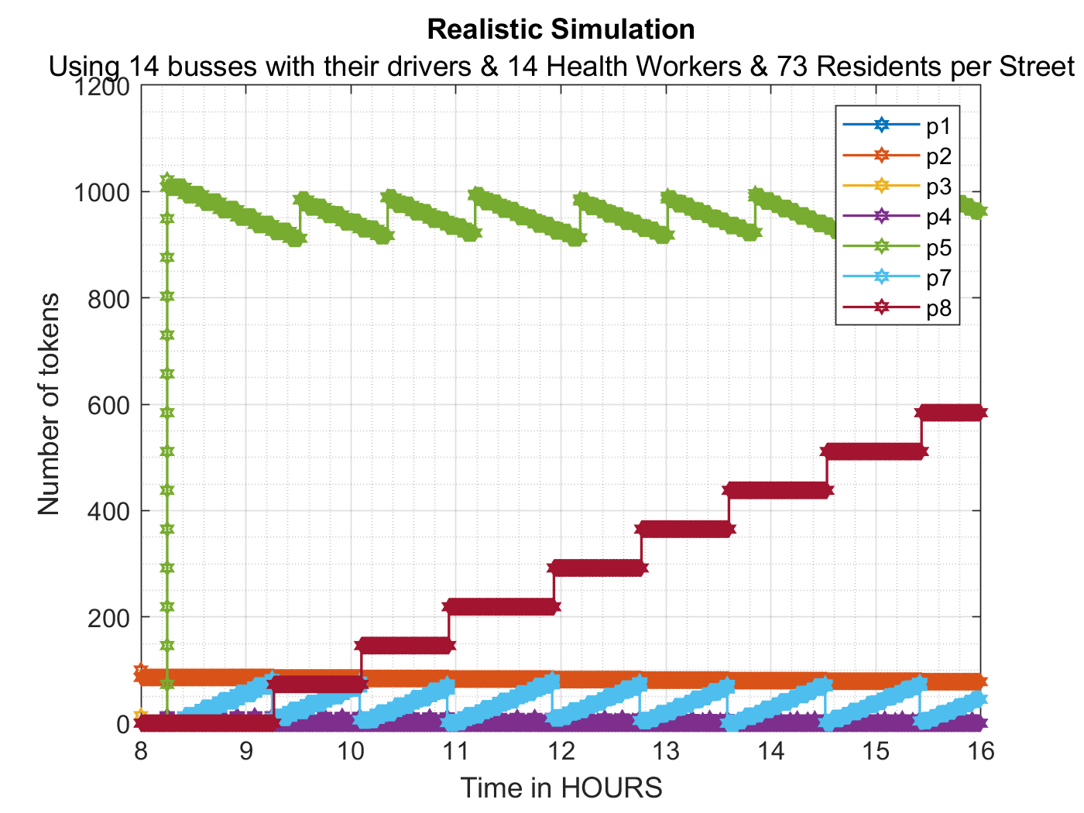

Figure 8, Simulation results of mobile vaccination using GPenSIM, and having a realistic set of available resources, consisting of 14 health personals, accompanied with 14 vaccination busses each having a dedicated bus driver.

According to the central bureau of statistics in Norway, 144 515 residents are living in the municipality of Stavanger by the 3rd quarter of 2021 [7].

And there exist 2021 streets in Stavanger according to the open data source provided by the website of the municipality of Stavanger [8]. However, it is important to mention that this available dataset contained multiple duplicates of the same street name due to its intended use in geographic analysis. But because we are interested in the unique streets of Stavanger, a MATLAB script was written to figure out the distinct number of streets in Stavanger from this dataset which was 2021 unique streets. This script is to be found under the following path in the attached source code:

**“/Mobile Vaccination/Plots, Data and Simulation Results/Data/estimating_avg_num_of_residents_per_street_in_Stavanger.m”**

Based on the total number of residents and the number of streets in the municipality of Stavanger, we can now calculate the average number of residents per street by dividing the total number of residents on the number of streets which gives the result of (144515 / 2021) ~ 73 residents per street. Please recall that this number is to be used as a weight for the arcs from the “tDISPATCH_*” transitions to the place “P5” to simulate the arrival of a vaccination bus at a new street, and from the arcs stretched from the place “P7” to the “tCOMPLETION_*” transitions to simulate the departure of a vaccination bus from a visited street.

Table 2 shows the state at the end of each simulation in Figures 7 and 8 respectively. And since we know that in centralized vaccination, we want to maximize the number of tokens at place “P5” because tokens at this place represent fully vaccinated and approved residents that have left the vaccination center after receiving a dose of the distributed vaccine. Also, the same logic is applied to the mobile vaccination but in this case, we should also take into account place “P7” in addition to place “P8” as both places contain tokens representing fully vaccinated residents.

Table 2, Shows the state at the end of a simulated working day in both programs of centralized and mobile vaccination, Tokens at place "P4" represent fully vaccinated and approved residents during centralized vaccination (shown in blue cells), and Tokens in the places “P7” and “P8” represent fully vaccinated residents during mobile vaccination (shown in green cells)

|  |  |  |  |
| --- | --- | --- | --- |
| Centralized Vaccination | | Mobile Vaccination | |
| Place | Number of Tokens | Place | Number of Tokens |
| P1 | 0 | P1 | 0 |
| P2 | 0 | P2 | 78 |
| P3 | 0 | P3 | 0 |
| P4 | 602 | P4 | 1 |
| P5 | 42 | P5 | 964 |
|  |  | P6 | 6658 |
|  |  | P7 | 45 |
|  |  | P8 | 584 |

Based on the overview of simulation results in table 2, we can calculate the number of working days it takes to vaccinate the 144 515 residents of Stavanger by dividing the number of residents by the number of fully vaccinated residents in this simulated working day, which gives us the results shown in table 3 below.

Table 3, Calculations of the needed number of working days to vaccinate all 144 515 residents of Stavanger per 2021 using the programs of centralized contra mobile mass vaccination.

|  |  |  |
| --- | --- | --- |
|  | Centralized Vaccination | Mobile Vaccination |
| Total number of residents in Stavanger | 144 515 | 144 515 |
| Number of fully vaccinated residents in one simulated working day | 602 | 45 + 584 = 629 |
| Number of working days need to vaccinate all residents in Stavanger | (144 515 / 602)  ~ 241 working days | (144 515 / 629)  ~ 229 working days |

The calculations in table 3 show that mobile vaccination can be expected to finish vaccinating all residents of the municipality of Stavanger 12 working days earlier than the centralized vaccination program.

However, it is important to notice that no delays are impacting the performance and progress of both vaccination programs in this simulation. However and in reality, many factors can impact the progress of each program just like a shortage of vaccine doses, sickness between personal or less operational vaccination busses or vaccination centers due to mechanical and logistical issues, but taking measures against such factors is behind the scope of this project and can be considered to be an improvement of this research in the future.

# **Future Improvements.**

The simulations performed in this project create a solid background for further research and studies that may answer the big question of how to deploy vaccines among the members of different societies in a fast and efficient way.

Many extensions and improvements can be added to the proposed workflows of both centralized and mobile vaccination. In this section, we are going to spot the light on some of these extensions and improvements that might have a greater advantage in future studies on this topic.

Starting from centralized vaccination, it can be useful to implement a random and/or variable visitor generator that controls both the time between arriving visitors and the number of visitors arriving at the same firing time, which enables a more realistic simulation as most people tend to not arrive right on time but rather a few minutes earlier or after their booked appointment.

It can also be interesting to study the effects of having multiple places between 2 stages where visitors wait to access the next stage, an example here is to have two token places between the vaccination and waiting stages, which represents two queues one for the younger people and one for the elderly, so the elderly can get prioritized to access the waiting rooms faster than younger people as we wish to minimize the standing in long lines for the elderly.

Implementing a scheduling queue algorithm between stages based on age or any other desired criteria is another similar thing to try to minimize the time when visitors wait to access the services of the next stage and hopefully this will help vaccinate more people in a desired and efficient way.

Examining the transitions in the Petri net of centralized and mobile vaccination, and how they grow in quantity when more resources are added to the system, it might be desirable to consider having one transition of each type and rather marking each visitor/token with an entry timestamp to know how much time he had access to a certain resource. This is especially important when the system does have a relatively big number of resources as the Petri net will get more and more complex with more transitions and arcs, but not to forget that each individual process of registration, vaccination, and waiting needs to take place in parallel with other processes in the system. This improvement should reduce the size of the proposed Petri net and makes it more scalable for the realistic use of available resources.

Moving on to mobile vaccination, it might be more realistic to use the actual number of residents in each street when running the vaccination process upon arrival of the vaccination bus at a targeted street. However, replacing the constant average number of residents by a variable number of residents requires us to find another solution to place the variable number of residents at a certain street in the place “P5”, “P7” and “P8”.

Scheduling algorithms can also have a great advantage in mobile vaccination to determine which streets to visit first, and/or which people to prioritize in receiving the vaccine, which can also carry an improving effect on the speed at which the system deploys the vaccine among residents of the targeted area.

On top of both vaccination programs, we can also integrate a new module or stage to handle the cases when people experience any unexpected reactions after receiving the vaccine. This enables us to simulate a larger picture of the actual vaccination program and its measures which helps ensure that the system will not be overloaded under such circumstances of exceptional cases.

We have now seen how some improvements can help in increasing the quality and performance of the simulations that are carried out in this project and provide a better understanding of the operations under each vaccination program.

*Conclusion*

Rewinding to the very beginning of this project, we had the objective of comparing the two different approaches of mass vaccination programs, namely centralized versus mobile vaccination. Based on that, a Petri net that visualizes the workflow of each vaccination program was proposed to be used as a foundation for the technical implementation of two respective computer simulations using the GPenSIM tool in MATLAB.

Each one of the two simulations was configured fairly to be nearly equal to the other in terms of available resources before comparing the results from each vaccination program. After running the simulations for one working day, we noticed that the mobile vaccination program was able to finish vaccinating 27 more residents in one working day and still use fewer material resources as no waiting rooms were needed because residents were to receive the vaccine at their homes. Taking this into a bigger picture, the municipality of Stavanger with its 144 515 residents and 2021 streets was used as a study case, where mobile vaccination could finish vaccinating all its residents 12 working days earlier than traditional centralized vaccination.

The results of the simulations carried out in this project raise the importance of simulating any vaccination strategy before adopting it as a vaccination program, running extensive simulations also increases the chances of choosing the most effective and suitable vaccination program.

Furthermore, it is highly recommended to use real data in running simulations to reflect the realistic picture of the actual situations. We also learned that further improvements in any of the workflow of the Petri net, technical implementation, or running parameters have a great potential of increasing the performance and reliability of the vaccination program and its simulation, along with revealing some advantages and downfalls in the system.

By the end of this project, great knowledge has been gained on how to build simulated systems and implement its workflow in an advanced computer simulation using the capabilities of the GPenSIM tools, and then analyze its results from a practical perspective.

##### **Acknowledgment**

A great thanks to dr. Reggie Davidrajuh for his excellent teaching of an interesting course under the topic of discrete simulation and performance analysis, which was offered by the University of Stavanger in Norway. And for his valuable contribution in developing and maintaining the GPenSIM tool, accompanied with many practical examples of features from the book called ***“Modeling Discrete-Event Systems with GPenSIM An Introduction” [6].*** The GPenSIM tool along with the last-mentioned book has been very useful for the progress of this research.

##### **References**

[1] Statista, Fatality rate of major virus outbreaks worldwide in the last 50 years as of 2020, 2021. Available: <https://www.statista.com/statistics/1095129/worldwide-fatality-rate-of-major-virus-outbreaks-in-the-last-50-years/>. Accessed on: 06.10.2021.

[2] The College of Physicians of Philadelphia, History of Vaccines, an educational resource by the college of physicians of Philadelphia, 2021. Available: <https://www.historyofvaccines.org/timeline/all>. Accessed on: 06.10.2021.

[3] James Lyle Peterson. 1981. Petri Net Theory and the Modeling of Systems. Prentice Hall PTR, USA. page 7.

[4] Smith IM, Smith DTL. Mass production methods for mass vaccination: improving flow and operational performance in a COVID-19 mass vaccination centre using Lean. BMJ Open Quality 2021;10:e001525. doi:10.1136/ bmjoq-2021-001525. Available at <https://bmjopenquality.bmj.com/content/bmjqir/10/3/e001525.full.pdf>. Accessed on: 20.10.2021

[5] Stanley A. Plotkin, Mass Vaccination: Global Aspects - Progress and Obstacles, 3rd ed. Berlin Heidelberg: Springer, 12. feb. 2010. Available at <https://books.google.no/books?id=Z1K73a84c6YC&lpg=PP1&hl=no&pg=PP8#v=onepage&q&f=false>. Accessed on: 23.10.2021

[6] Reggie Davidrajuh, Modeling Discrete-Event Systems with GPenSIM An Introduction, 1st ed. Cham: Imprint Springer; Springer International Publishing, 2018. Available at https://link.springer.com/content/pdf/10.1007%2F978-3-319-73102-5.pdf. Accessed on: 23.10.2021

[7] Statistics Norway, 2021. Available: <https://www.ssb.no/kommunefakta/stavanger>. Accessed on: 22.11.2021.

[8] The Municipality of Stavanger, Online Open Data, 2021. Available: <https://open.stavanger.kommune.no/dataset/gatenavn-stavanger>. Accessed on: 22.11.2021.

1. A Petri net is composed of four parts: a set of places P, a set of transitions T, an input function I, and an output function O. [3]